**EXPERIMENT 2- LED CHASER**

Circuit Diagram:

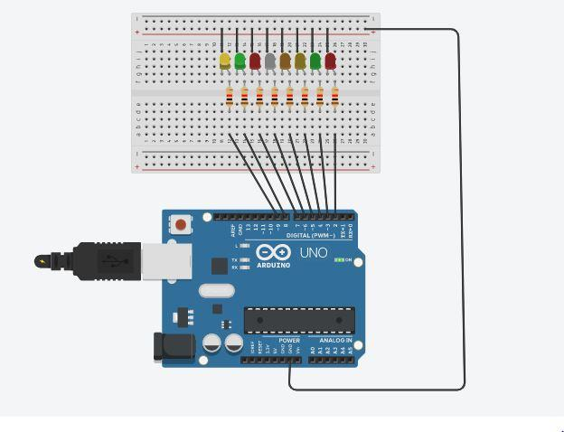

Theory:

Concept used:

* Combination of LEDs in parallel circuit
* Use multiple digital pins of Arduino Uno at the same time.
* CODING to obtain chaser effect
* Connections in Breadboard CIRCUITS.

Learning and Observations:

In this experiment we learnt about:

* Code used in Arduino Uno.
* Interfacing of multiple LEDs with Arduino Uno board and Breadboard.
* We learnt about LEDs parallel combination.

Observations:

* Observation is when we change delay it change the whole pattern of the chaser.
* If we don’t use delay in our code at specific points we get a continues pattern.

Precautions:

1. The connection of LEDs should be proper.
2. Define each pin in the code, which we used for output.
3. Declare all the ports properly.
4. Ensure that positive terminals of LEDs are connected to the Arduino digital input/output pins and the negative terminal to the ground pin.

Learning Outcomes:

1. How to use multiple pins at the same time to give output.

1. Understanding the connections inside the Bread Board.